Create and configure IBM cloud services

**Creation of node-RED**

|  |  |
| --- | --- |
| Date | 02 November 2022 |
| Team ID | PNT2022TMID51261 |
| Project Name | Project - Real-time River  Water Quality Monitoring and Control System |
| Maximum Marks | 4 Marks |

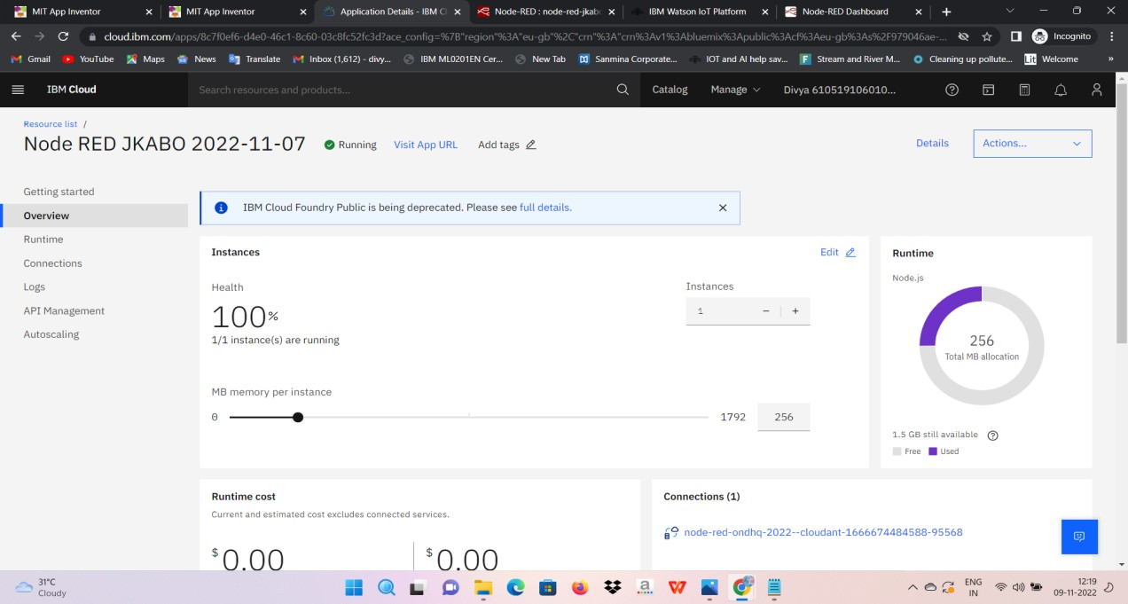**NODE RED**

